ASPN Workforce Committee: Crash-Course on Telehealth
March 26, 2020

Sample Language 1:
This was a virtual (video/audio visit) in lieu of in-person visit due to the coronavirus emergency.
Patient/Family members identity was confirmed and confidentiality/privacy confirmed prior to visit. Verbal informed consent was obtained from the patient's legal guardian or patient when appropriate to conduct this virtual visit. They authorized me to provide medical care and voiced understanding of the risks, benefits, and alternatives of virtual care. Guardian understands the limitations inherent of a virtual visit, that they may choose to be seen in person if desired or needed, and that they may halt the virtual visit at any time for any reason.
Originating Site: ***
Distant Site: ***
I certify that this visit was done via secure two-way simultaneous audio and video transmission with informed consent of the patient and/or guardian. Over 50% of the time was counseling or coordinating care.
Sample Language 2: (auto-text using dropdowns)
Present for Televisit
Patient/Family: Parent/guardian only OR Patient only OR Patient & parent/guardian
Providers/Team Members: _
Visit Details
Consent for visit to be conducted by Telehealth: Verbal consent from parent/guardian OR patient
Consent for treatment: Verbal consent from parent/guardian OR patient
Modality: Audio-Visual OR Audio only
Patient/Family Physical Location: Personal residence in state of _
Provider Physical Location: Personal residence in state of _
Supervising faculty attending: Personal residence in stage of _
Time Attestation
Time call/video started: _
Time call/video ended: _
Total time: _ minutes

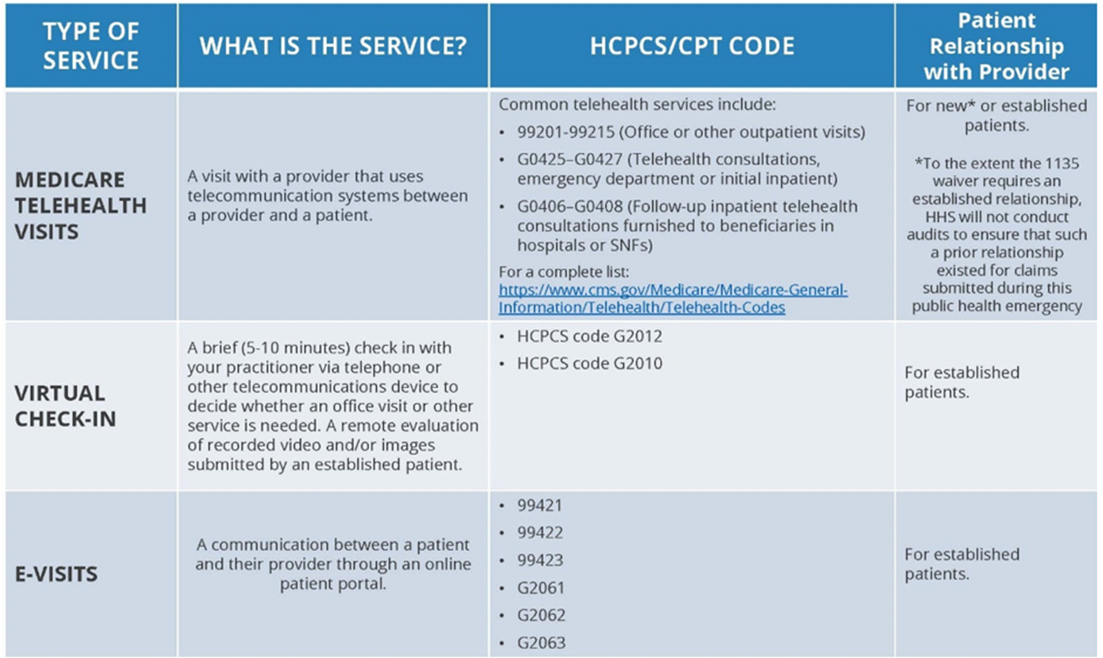

Sample physical exam for telehealth visits:
General: No apparent distress. Awake, alert, well-appearing.
HEENT: Normocephalic and atraumatic. Mucous membranes are moist. No periorbital edema. Facial muscles move symmetrically.
Neck: Neck is symmetrical with trachea midline.
Eyes: Conjunctiva and eyelids normal bilaterally. Pupils equal and round bilaterally.
Respiratory: breathing unlabored, no tachypnea.
Cardiovascular: No edema, no pallor, no cyanosis.
Abdomen: Non-distended.
Skin: No concerning rash or lesions observed on exposed skin.
Extremities: Wide range of motion observed. No peripheral edema.
Neuro: Mood and behavior appropriate for age.
Musculoskeletal: Symmetric and appropriate movements of extremities.

